**Tomcat server setup and configuration:**

Download link: <https://archive.apache.org/dist/tomcat/tomcat-8/v8.5.0/bin/>

* **To Setup Tomcat server :**

**Step 1)**  After downloading the unzip file and rename the folder name as **enterprisetomcat8** and place this folder in **D:\EnterpriseApplication.**

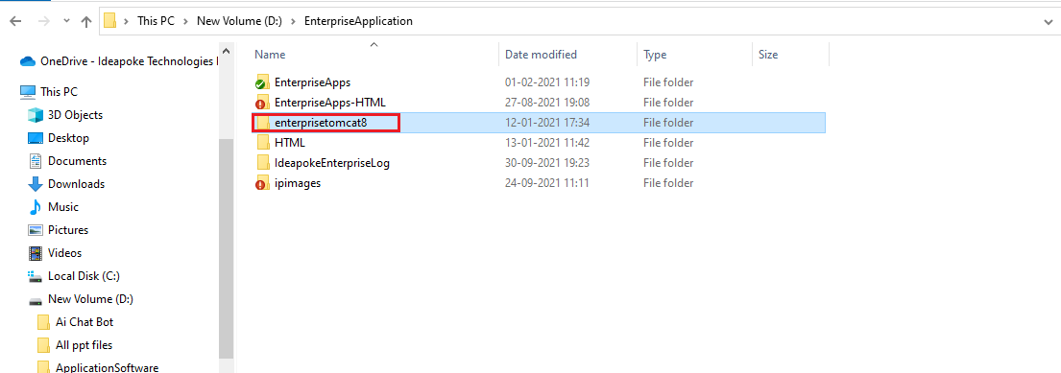

**Step 2)** Right Click on the My Computer and Select the properties

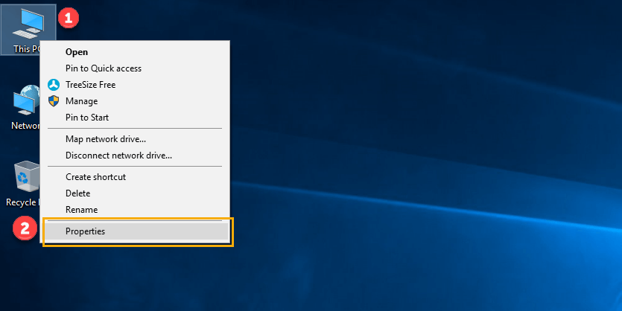

**Step 3)** Click on advanced system settings

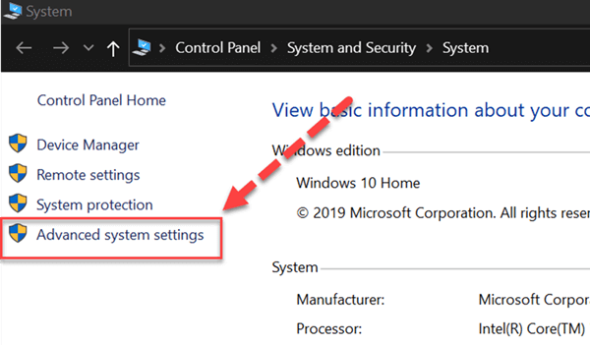

**Step 4)** Click on Environment Variables to set Java runtime environment

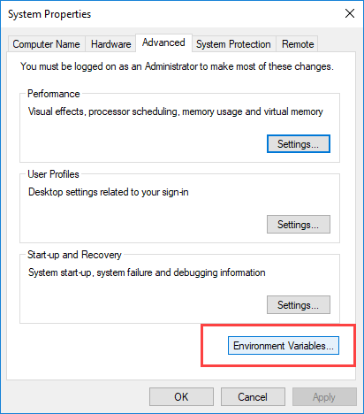

**Step 5)** click on **New** in system variables

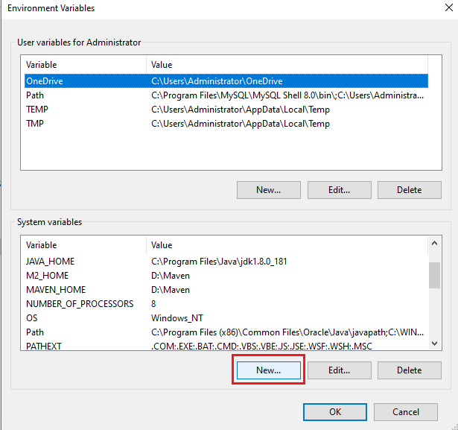

**Step 6)** Enter the variable name as **CATALINA_HOME** and variable value as **D:\EnterpriseApplication\enterprisetomcat8**, then click on **Ok .**

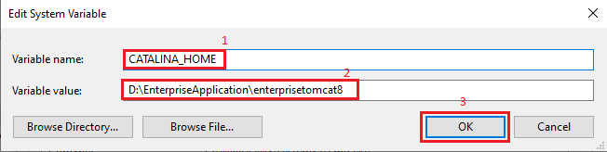

**Step 8)** Click on **OK** button

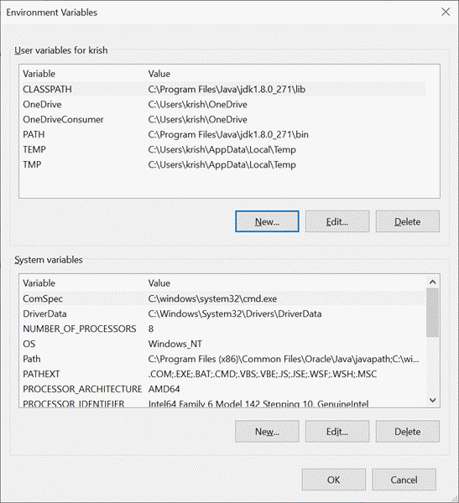

**Step 9)** Go to **D:\EnterpriseApplication\enterprisetomcat8\bin** and click on **startup.bat file** to start the tomcat server.

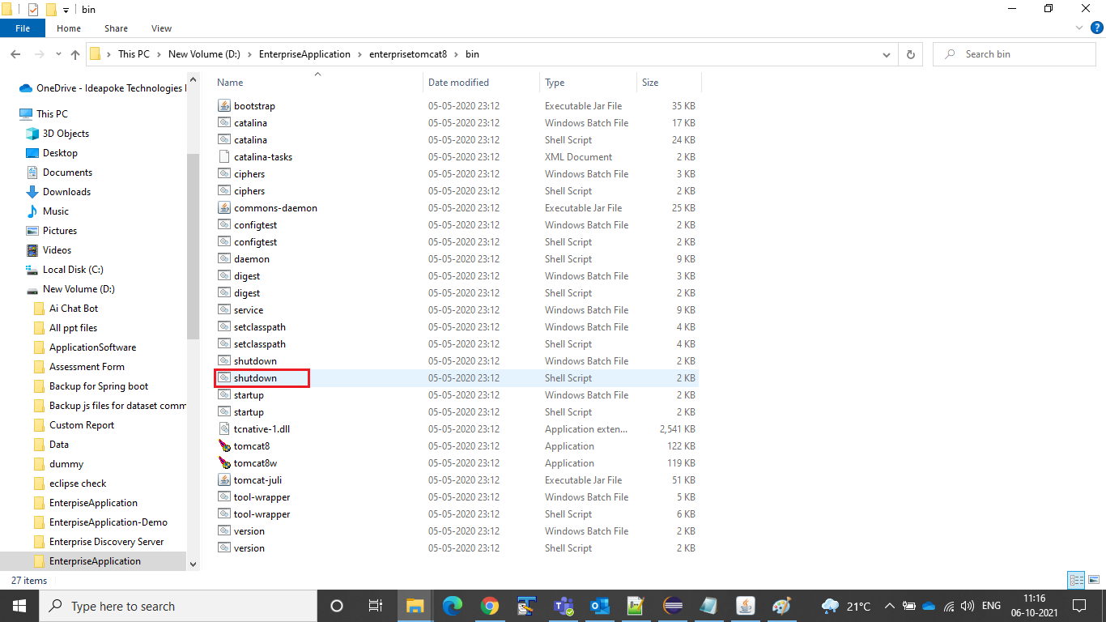

**Step 10)** Here you can confirm Tomcat server has started or not.

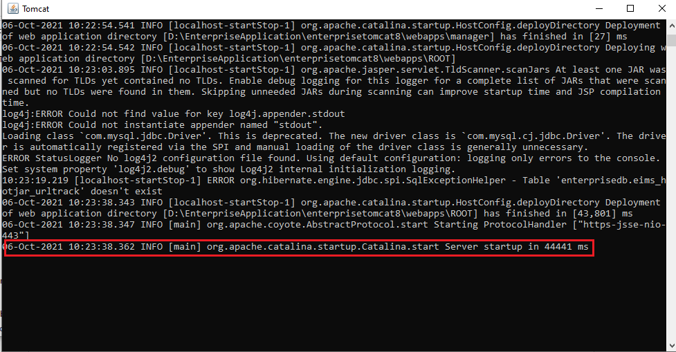

**Note:** To stop the Tomcat server press **Ctrl + C**

**Step 11)** Go to Web browser, type in search bar as <http://localhost:8080> and you can see the tomcat screen as mentioned below.

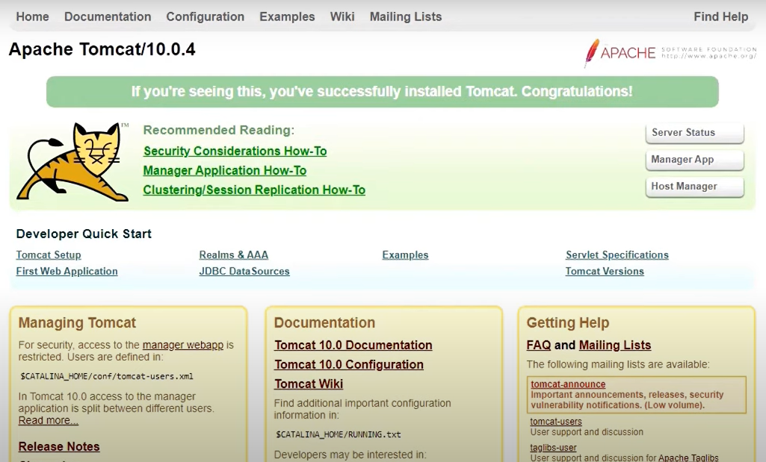

**Note:** This works only when the server is started up.

* **To configure Tomcat server for Enterprise Application:**

**Step 1)** Open **server.xml** file from the path **D:\EnterpriseApplication\enterprisetomcat8\conf** in any of the text editor.

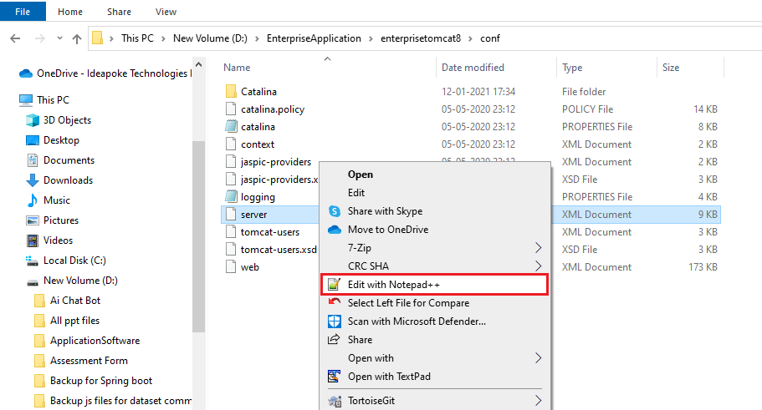

**Step 2)** Go to the line number **69** and change the port number from **‘8080’** to **‘80’** and add the below lines of code after line number **71** and save it.

<Connector port="443" maxHttpHeaderSize="8192" maxThreads="150" maxPostSize="-1" minSpareThreads="25" maxSpareThreads="75" enableLookups="false" disableUploadTimeout="true" acceptCount="100" scheme="https" secure="true" SSLEnabled="true" clientAuth="false" sslProtocol="TLS" keyAlias="tomcat" keystoreFile="D:/tomcat.keystore" keystorePass="ideapoke" URIEncoding="UTF-8" />

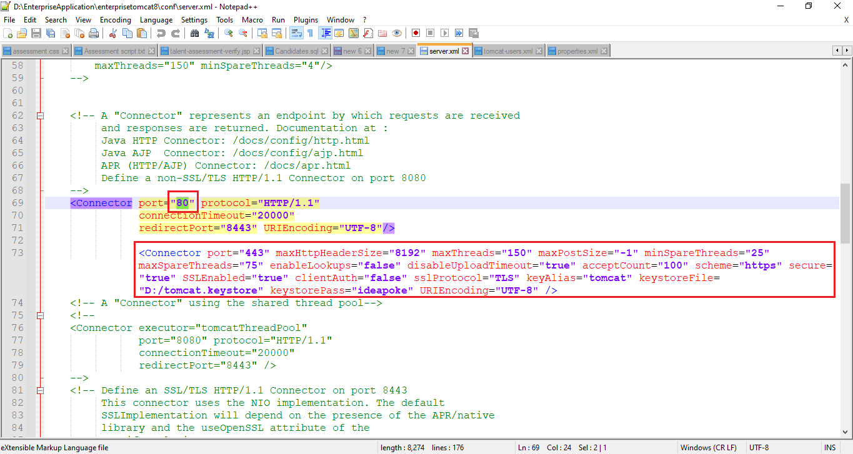

**Note:** Make sure that you Keeping the downloaded tomcat.keystore file in D drive.

**Step 3)** To Add ipimages path in **server.xml** file, copy the below lines of code and paste it after line number **168** and save it.

<Context path="/ipimages" docBase="D:/EnterpriseApplication/ipimages" crossContext="true" />

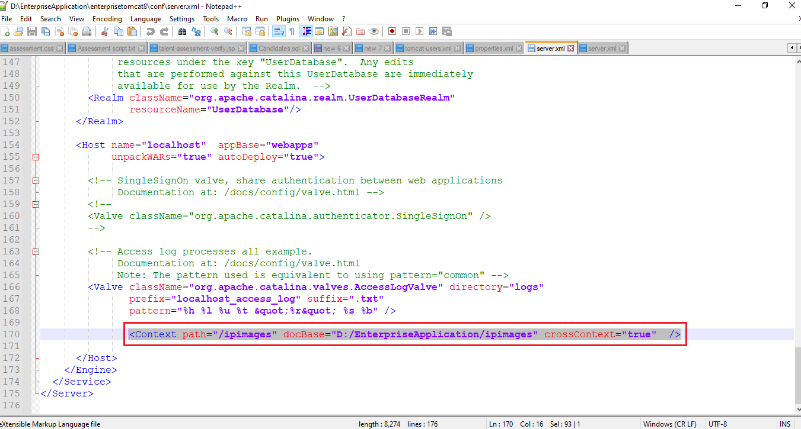

**Step 4)** Next, copy paste the below path in the address bar of windows explorer **D:\EnterpriseApplication\enterprisetomcat8\webapps\ROOT\WEB-INF**

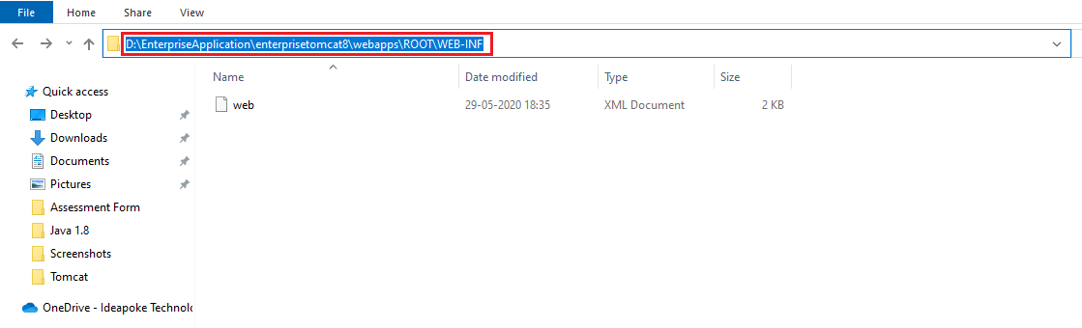

**Step 5)** Copy the downloaded **classes** folder**, lib** folder and **dispatcher-servlet** file and paste it.

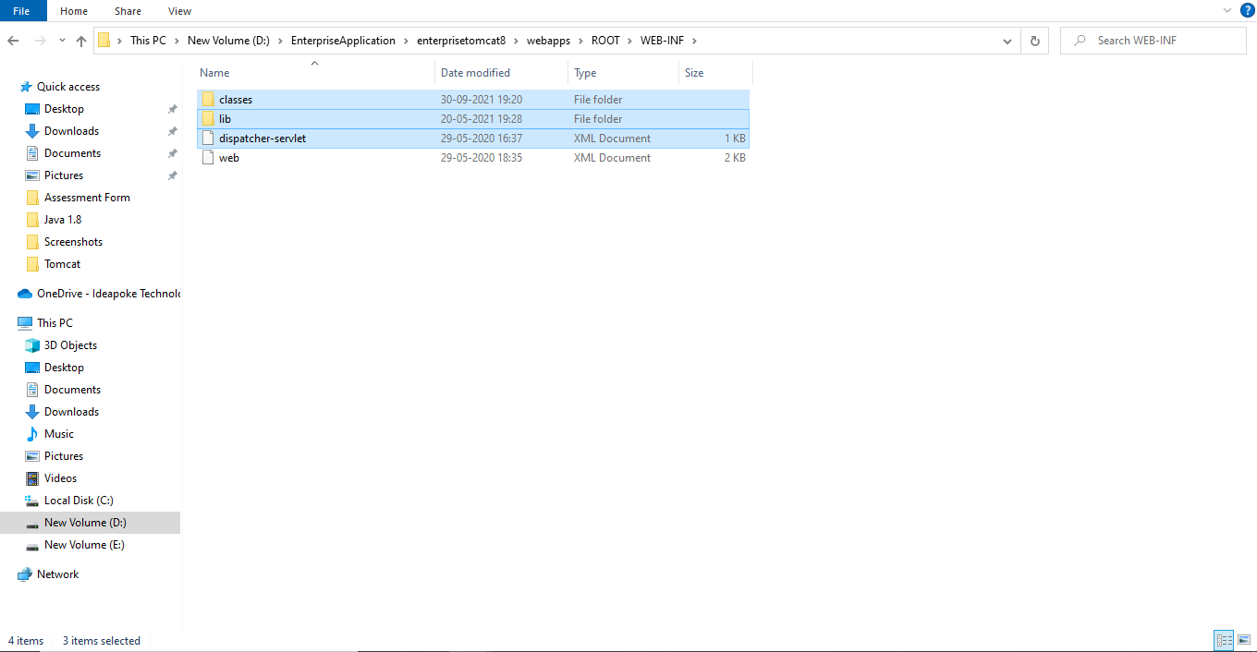

**Step 6)** To Setup **JDBC** connection and **Hibernate** Configuration in **config.properties** file from the path **D:\EnterpriseApplication\enterprisetomcat8\webapps\ROOT\WEB-INF\classes.**

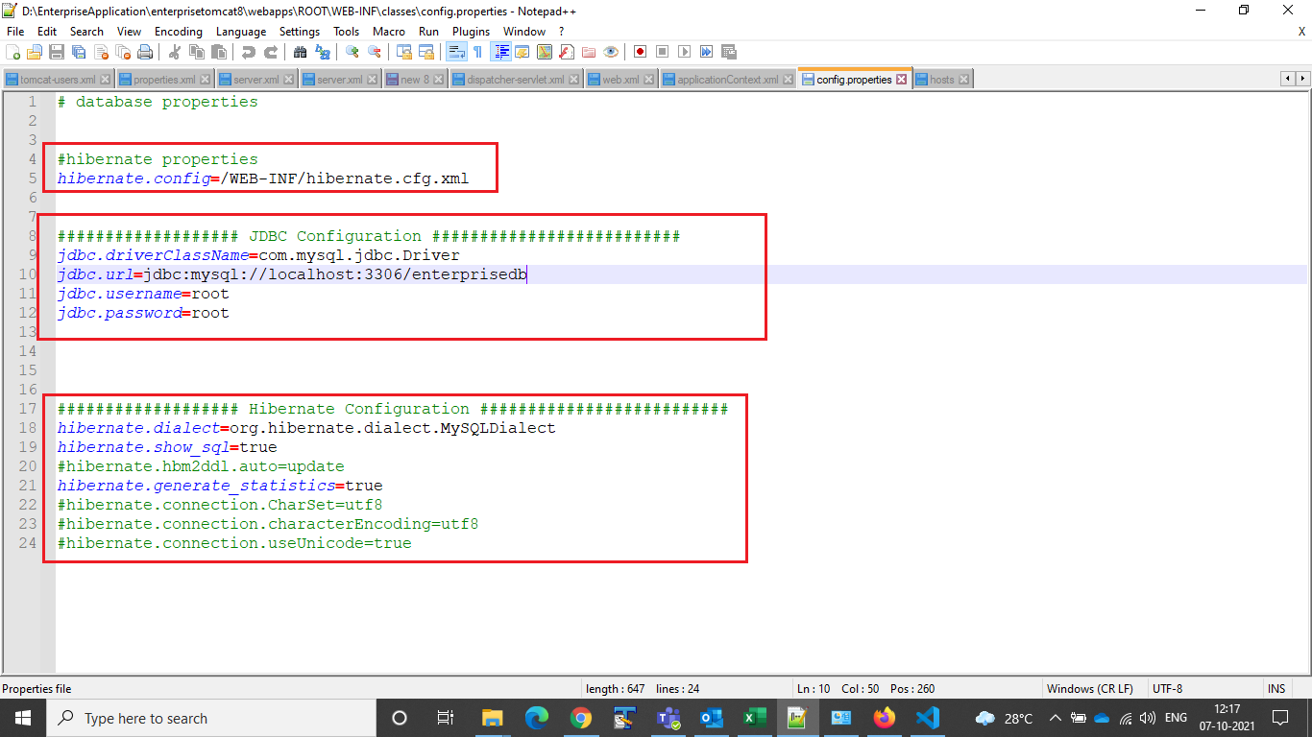

**Step 7)** In **applicationContext.xml** file we are making use of **JDBC** connection and **Hibernate** Configuration values from **config.properties** file from the path **D:\EnterpriseApplication\enterprisetomcat8\webapps\ROOT\WEB-INF\classes**

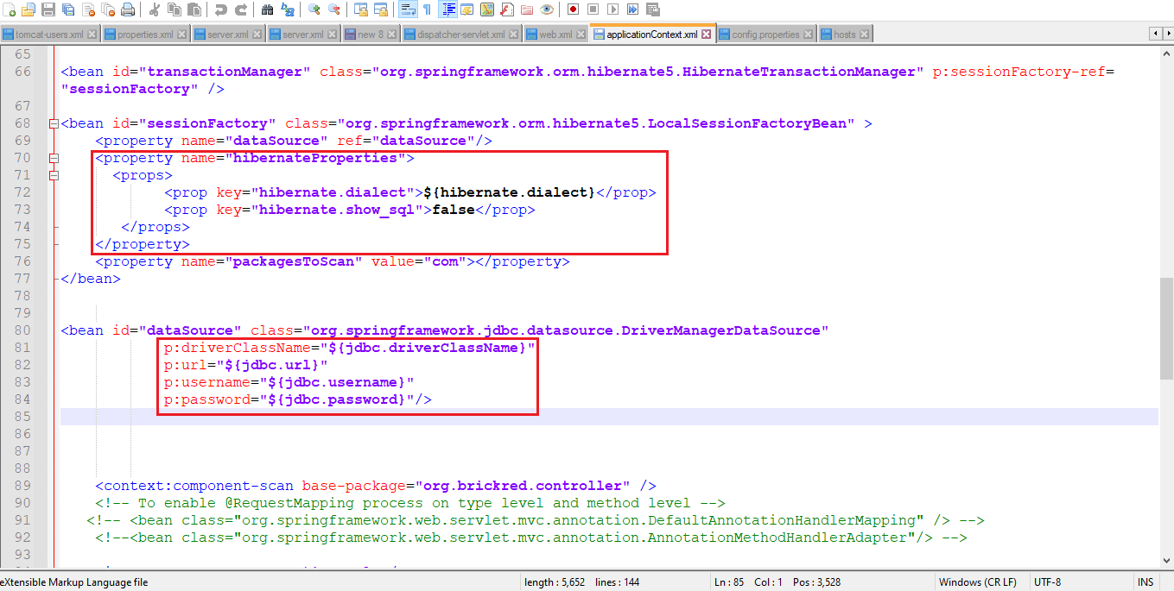

**Step 8)** Press **Win + R** keys from the keyboard and type **drivers** and Click on **OK.**

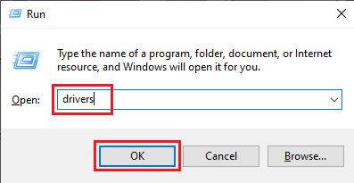

**Step 9)** Go to **etc** folder.

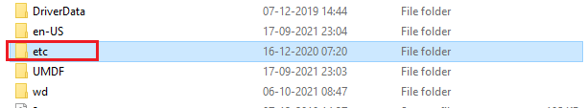

Right click on **hosts** file and open.

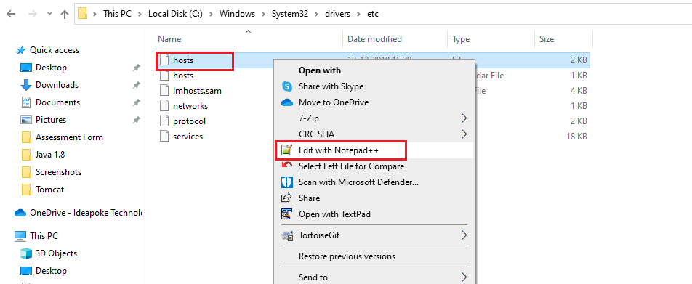

**Step 10)** Give the Domain name as **ideaprime.com** in **hosts** fileas show below and save it.

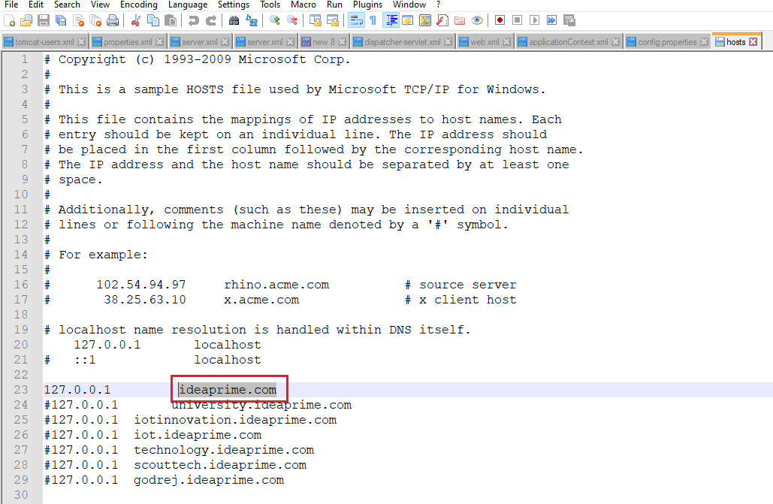

* **To Copy the Build files from Enterprise Application and Deploy it in Tomcat Server.**

**Step 1)** Once the Build is Successful from the eclipse. Go to **D:\EnterpriseApplication\EnterpriseApps\EnterpriseApps\target\classes** this path and copy the **com** folder.

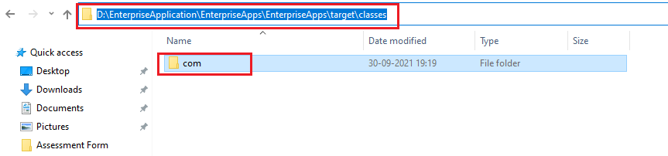

**Step 2)** Then go to **D:\EnterpriseApplication\enterprisetomcat8\webapps\ROOT\WEB-INF\classes** and paste the copied **com** folder here.

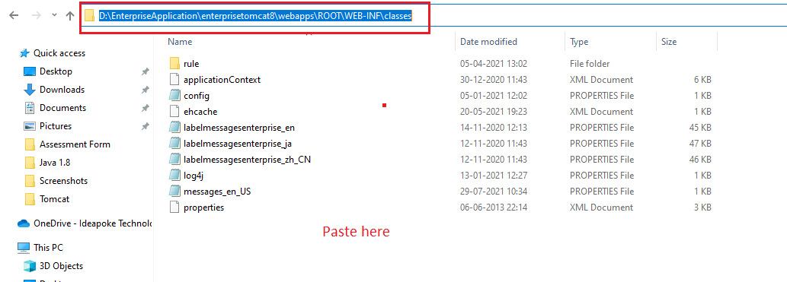

**Step 3)** To start the server, repeat the **step 9** and **step 10** from Tomcat setup from the aove slides and then, Go to web browser and type <https://ideaprime.com> , click on **enter** and you can see screen as mention below.

**Step 4)** To See the Tomcat server logs, go to **D:\EnterpriseApplication\enterprisetomcat8\logs** this path and you can see the log files.

